The Mixed Nuts
Set LL Last revised on 2016.07.30
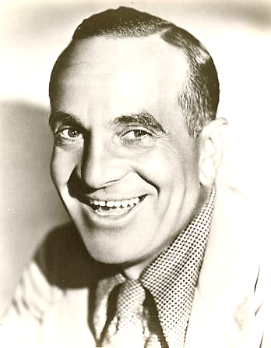
LL01-Three Little Words(KVF).pdf
LL01-Three Little Words(KVM).pdf
LL02-I Wonder Who's Kissing Her Now(KV).pdf
LL03-What Is This Thing Called Love(KVF).2016.07.30.pdf
LL03-What Is This Thing Called Love(KVM).2016.07.30.pdf
LL04-You Call Everybody Darling(KVD).2016.07.30.pdf
LL05-Don't Worry 'Bout Me(KVF).2016.07.30.pdf
LL05-Don't Worry 'Bout Me(KVM).2016.07.30.pdf
LL06-Hello, Mary Lou Polka(KV).pdf
LL07-Learning The Blues(KVF).2015.08.02.pdf
LL07-Learning The Blues(KVM).2015.08.02.pdf
LL08-Somebody Stole My Gal(KV).pdf
LL09-You Made Me Love You(KVF).pdf
LL09-You Made Me Love You(KVM).pdf
LL10-Toot, Toot, Tootsie(KV).2015.08.02.pdf
LL11-April Showers(KVF).2015.08.02.pdf
LL11-April Showers(KVM).2015.08.02.pdf
LL12-Glory Of Love, The(KVF).2016.07.30.pdf
LL12-Glory Of Love, The(KVM).2016.07.30.pdf
LL13-That's All(KVF).2015.08.02.pdf
LL13-That's All(KVM).2015.08.02.pdf
LL14-It's A Sin To Tell A Lie(KVF).pdf
LL14-It's A Sin To Tell A Lie(KVM).pdf
LL15-Love Letters(KVF).pdf
LL15-Love Letters(KVM).pdf
LL16-Enjoy Yourself(KV).2016.07.30.pdf
LL17-'Taint What You Do(KVF).pdf

LL17-'Taint What You Do(KVM).pdfLL01-Three Little Words(KVF).pdf

